Lower the player health / decrease light intensity on campfires/ rune stones.

MDA analysis
Write about how these will change in the different game modes for example pooling currency for a bigger wave becomes redundant.
Mechanics
Bow and Arrow Velocity.
Time/ Player Health (Win Conditions).
In Game chat.
Currency (Increments over-time).
Multiple Monster Choices.
Tiled Spawning mechanics.
Fires linked to player health (Light intensity).
Rune Stones activate when 10 or more enemies are on the field slowing enemies.

Dynamics
Spawning monsters closer to the VR player.
Saving currency for larger waves of monsters.
Players talking to each other.
VR player feels immersed as bow replicates real physics.
Time adds constraints and a sense of strategy.
Lower health means less light adding tension/ panic.
Punishment for spawning too many enemies.
Aesthetics
Challenge- Both players will have something new to master, while competing against each other. This will bring players back to the game as there are several level of challenge.
Fellowship- Being able to talk while playing the game will add a social element to the game.
Sensation- Using asymmetric gameplay with VR, it will allow players to experience something completely new.
Fantasy- Both the VR and PC player will experience a sense of immersion in a new world.

Enemy types-
Enemy | Description | Picture
Raptors | Quick small 1 hit point of life, cheap cost. Quick spawn time. | 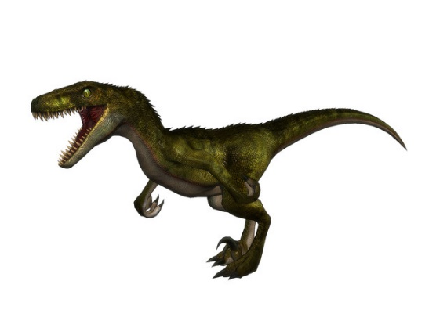
Skeletons | Slower spawn time, cheapest unit, medium speed, 1 hit point, chance on hit to not die. 1/10. | 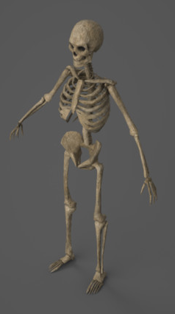
Ogres | Slow tank unit. Expensive, 3 hit points. Once has been hit twice becomes enraged increasing speed. Medium spawn time. | 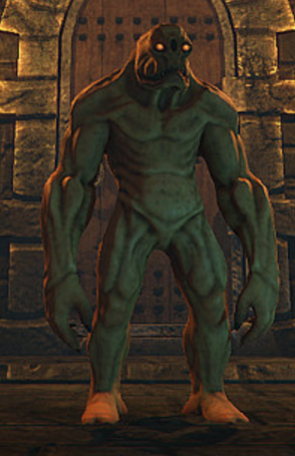

Currency-
Each enemy has different currency and increments differently (each unit costs 1 of its given currency). This will be redundant in the imbalanced game mode as the player will have no constraints.
Enemy | Currency
Raptor | Raptor Food, Starts at 20, increments +10 a minute.
Skeleton | Skeleton Souls, Starts at 20, increments +10 a minute.
Ogre | Ogre Gems, Starts at 10, increments +5 a minute.

Spawning-
Balanced game mode- Tiles time out meaning monsters cannot be spawned there again for 20 seconds. The tiles will be split into 3 categories;
Close to the VR player, these will add time to the game.
Medium distance, has no change.
Furthest away from VR player, these remove time from the game.
Imbalanced game mode-
No tile has any consequence or benefit and can be used as many times as the PC player likes.
Player (PC) Camera/ Controls-
RTS camera. Clickable side buttons on a GUI. Main GUI on bottom of the screen with the time being behind the VR player. There will also be hot keys the player can use instead of clicking on buttons.
Player (VR) Camera/Controls-
Bow and Arrow- The player will be able to switch controllers depending on their preference. Information will be displayed to the player via rendered text being drawn to the floor in front of them.

Winning/ losing conditions-
 | Win Condition | Losing condition
PC Player | VR player’s health is less than 0. | Time reaches 5 minutes.
VR Player | Time Reaches 5 minutes and they have more than 0 health. | Health reaches 0.

Scripted events-
 | Description | Picture
Campfires dimming with health. | The Campfires light intensity is linked to the player’s health. Upon taking damage this lowers.
Rune Stones | If more than 10 monsters are on the field at once, the Rune stones will activate slowing enemy movement speed for 20 seconds. Has 30 second cool down.

